

St John church and St Leonard church center, Bedford

APCM report 2025
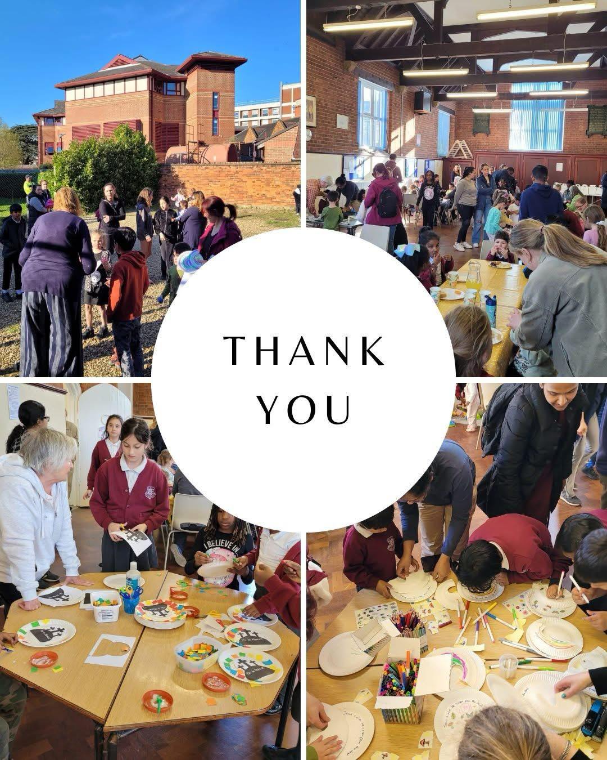

Contents:
Church Wardens report | Page 3-5
Safeguarding report | Page 5-6
Treasurers report | Page 6-10
Lay chair report | Page 11-12
Babies & Toddlers report | Page 12-14
Worship report | Page 14-15
Buildings & Land report | Page 15-17
Environment report | Page 17-18
Lizzie & Dan’s Home group report | Page 18-19
Coffee morning report | Page 19-20
Monthly prayer report | Page 20

Churchwardens Report for 2024
We had our first social even on 13th February when we celebrated Shrove Tuesday with Pancakes at St John's Hall. This was very well attended with lots of different topping for the pancakes. Sadly at the end of February Tracey left us to move away and she is greatly missed. We had a farewell lunch for her giving her some books and garden voucher. This meant that different members of the Standing Committee plus Margaret Lambert have taken over her duties.
In March Impact used St John's church for their Easter Experience. The event was well attended by school children and their helpers/teachers. There was also a chance for those who support Impact to come and see the Easter story. In December Impact also used St John's church for their Christmas Nativity which was also well attended. Our second social event was an Easter Party which was held on 27th March at St Leonard's. This was also well attended with families from Toddlers and Cauldwell School. There was fun and games for the children plus of course Easter Eggs.
Our Good Friday service was held at St Leonard's which was reflective with Hot Cross buns afterwards thanks to Sylvia. Then on Sunday we celebrated our risen Christ at St John's. The adults were given an Easter Egg and the children had an Easter Egg hunt in the hall. At the end of May Helen went on Maternity leave and we thank God for the birth of Isabelle. This meant we have had different retired members of clergy taking our Holy Communion services at St John's and we have been very blessed with their message to us. Even though Helen has been on maternity leave she has been able to attend our Standing Committee and PCC meetings which we are very grateful for and lead some services. Also popping into the office which means a cuddle of Isabelle for Hilary. On July 24* we held our Fun Day based on the Olympics. This was held at St Leonard's and was a great success.
On Sunday 15th September we celebrated our harvest at St John's when we were very blessed to have Bishop Richard lead the Holy Communion Service. When with both financial giving and bringing food gifts thanked God for his provision for us. St Leonard's celebrated their Harvest the following Sunday. Our aim is to reach out to the parish and this we did by having a Light Party on 31st October held at St Leonard's from 4pm. This was advertised locally and in Cauldwell School, plus our 2 Babes and Toddler Groups. It was well supported and we even had to turn families away. We had over 70 children plus adults.
The second reach out was the Christingle Service which it was decided to hold on Wednesday 11™ December 4pm at St Leonard's and again was advertised as the Light Party before. We had approximately 35 children plus adults. attended and the highlight was David Lambert was a scientist although things did not go as planned.
There was games for the children and afterwards there was food for everyone. We had our Candlelit Carol Service on Sunday 22"d December we had our Crib service at St John's. We only had one extra family with us but the children took part in the Christmas story and dressed up. In the evening we had our Candlelit Carol Service with a choir and mulled wine and mince pies afterwards. Our Midnight Communion at St John's on 24th December at 11.30pm was only attended by 8 people this year. Christmas morning we celebrated the birth of our Lord at St John's as a family service. During the year we are still having problems with drug addicts using our site at St John's and leaving litter and needles about. We would like to thank Bedford Council for coming to clear our glebe land.

Both our Babes and Toddler Groups have been well attended and we would like to thank God that numbers at St Leonard's have increased. We would like to thank Alison and her band of helpers who throughout the year have been running these two groups. We have also been blessed by advertising St John's Hall and St Leonard's church centre on our website for hire for children's parties etc. This has brought in extra revenue for us. This we hope will increase during the coming year. We would like to thank God that we have had new families and this has involved us with producing activities for the children during the sermons. Thanking Helen for arranging the room in the vestry for them to go out to.

Finally we would like to thank God for providing for us during this past year and for Helen as she leads us. Also to thank you all for your support and prayers while Helen has been on maternity leave.

Safeguarding Report for March 2025 PCC Meeting

We remain compliant regarding DBS checks and training.
As you will be aware, the topic of Safeguarding in the Church of England has been high on the agenda for several months now. There are bound to be some changes in light of the recent reports. I will let you know about them when they occur.
For your information, l attach a report from General Synod on the debate on Safeguarding, which gives a more accurate version of what was discussed. Please take the time to read this. You will have read the latest Diocesan Training Newsletter which came out in February. There was a great deal of information in this. I will be attending a forum for PSO's in April to go through the changes detailed in this newsletter, and hope to have more information in due course.

There was some confusion as to whether PCC members needed to do the Awareness of Domestic Violence course. However, it is recommended by the Diocesan Safeguarding Leads that members of the PCC should undertake this, and Helen Stewart and I agree, so all members (except those who have completed this course within the last three years will need to renew this training. I will be sending out reminders shortly. The Safeguarding Policy for St John's & St Leonard's is now displayed in all our church buildings. This must be reviewed/renewed annually.
The new Safeguarding Standards poster issued by the Church of England Safeguarding Board has been put up in each church building. We have not yet, as a PCC, started looking at the Safeguarding Standards as you will recall that Dave Middlebrook (Archdeacon) advised Helen that this should be done after Helen returns from her Maternity Leave. Unfortunately, we shall be away for the May PCC, so I recommend (following discussion with Standing Committee) that this is taken forward to the July PCC for discussion.

Treasurer's Report for the APCM April 2025

The multi-page Annual Report and Accounts 2024 (a separate document) is made up of the following sections:
i) Annual Report 2024 (pages 1-9)
ii) Statement of Financial Activities [SOFA] (page 10)
iii) Charity Commission Balance Sheet (by Funds) (page 11)
iv) Notes to Accounts - 1 (page 12)
v) Notes to Accounts - 2 (page 13) vi) Pensions statement (page 14)
Vii) Examiner's Report (page 15)
vili) Record of giving to the Diocese (Parish Share) (page 16)
In addition, at the end of this Treasurer's report, you will also find ix) YE 2024, Budget 2025_summary (1 page)

1. 2024 Annual Report and Accounts
The Annual Report and Accounts is a statement of our work and witness as a church, as well as being a legal document demonstrating how we have fulfilled our charitable purposes during 2024. The Annual Report and Accounts have been independently examined by Barrie Frost, and were approved by the PCC at their March meeting. Thank you to those who compiled the non-financial part of the report, and on the accounts side of things I would like to thank members of the finance team, and most especially Angela Locke for all her work (and patience) over the past year.

Aside from the formal Report and Accounts, section ix) (below) provides an overview of the 2024 finances, with diagrams summarising our income and expenditure.
The finance section of the annual report covers the 'highlights' of our income and expenditure in 2024. Suffice it to say here, our overall deficit was considerably lower than budgeted, the major factor being our lack of a paid administrator for much of the year.

Please read the report for more information.
- ﻿﻿﻿The APCM is required to agree an examiner for the 2025 report and accounts, and on behalf of the PCC I propose Barrie Frost, who has been our examiner since 2010, and who has indicated that he is willing to perform this task once again.
- ﻿﻿﻿2025 Budget
The PCC approved the budget for 2025 at the March meeting, and a summary can be found at the end of this report (document ix) already referred to).

The headline figure of a deficit of £58,000 needs some explanation to place it in context, and I will say more in the meeting. But here are some pointers ...
First, and most significant, we could potentially spend up to £30,000 from our Fabric Fund (that is, money set aside to pay for work on the fabric of St John's Church only, it can't be spent on anything else). This in response to the most recent Quinquennial survey of the church building. The Fabric Fund itself gets topped up each year by dividends received from the underlying (protected) investments.

Second, as agreed by the PCC in January, and further to the survey of church members undertaken before Christmas, we plan to spend some £7,000 from money earmarked from Josie Line's generous legacy, originally planned to spread over the last three years. This money will go to support mission partners with whom we are linked.

Third, we have provisionally allocated £5,000 to spend on the Curate's house, although this is subject to further discussion and decision at PCC. As noted in the Annual Report and Accounts, we do own this building outright. We can expect that any expenditure on this property would allow us to increase the rent we receive, so the expenditure would pay for itself in due course. But this is a matter for the new PCC going forward.

Putting these sums to one side, as one-off or recoupable expenses, we are left with a deficit of around £16,000 on our regular income/expenditure account, around half the size of the deficit budgeted for in 2024. Amongst other factors, the 2024 budget included a large one-off photocopier payment, not repeated this year, and our energy bills in 2025 will be significantly lower following the start of a new contract last October.

Whilst the projected deficit on regular income/expenditure is lower, we do need to continue to reduce it further, as in the long term we cannot sustain this. We are grateful to God for those who give faithfully and sacrificially to God's work here, as well as for Josie's legacy, which enables us to sustain these losses in the near term.
Let's not use financial words for a moment. What we're talking about here is enabling our mission and ministry, as a church, for God's Kingdom here in Bedford. What we spend our money on is all about supporting our worship, our discipleship, our pastoral care, our community service and outreach, and we believe it is right to continue with this work (and more) even if that means spending more than we receive in the short term.

As a church we do have major assets in our land and buildings, which already generate nearly 40% of our income; but we aim to make even greater use of these assets to generate more income to support our mission and balance our books. It would be fair to say that our plans have been somewhat 'on hold' during Helen's maternity leave, but now that she is back the new PCC will be addressing this head on.

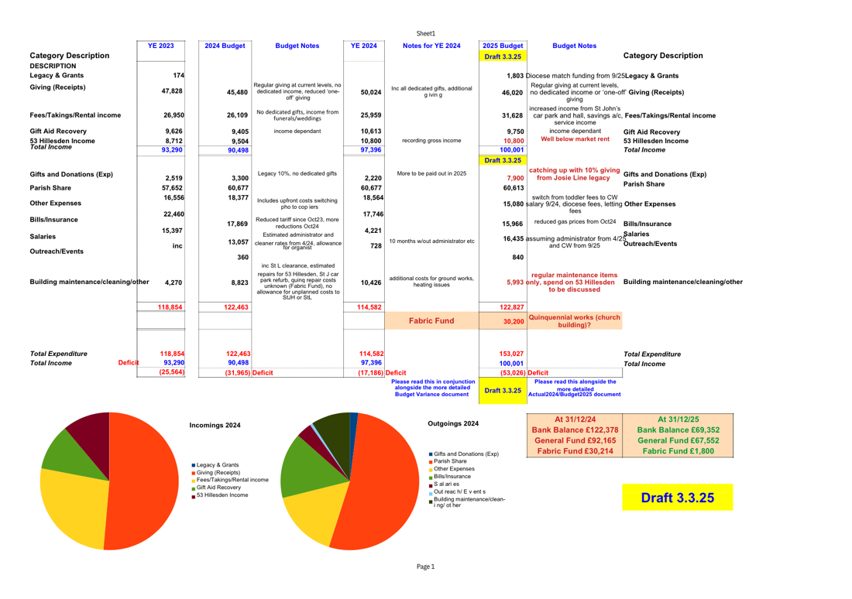
Lay Chair Report for 2024

As mentioned in the Annual Report, the full PCC met 6 times over the past year, with good attendance throughout.In the absence of a parish administrator, we are very grateful to Margaret Lambert, Lizzie Payton and more recently Helen Stewart who have taken on the responsibility for taking the Minutes of the PCC and some of the responsibilities belonging to the PCC secretary.

It has been wonderful that Helen has been able and willing to come to both PCC and Standing committee meetings throughout her maternity leave and we are very grateful for her dedication and guidance. Thank you to everyone who has served on the PCC this year; for your commitment and input, for your questions, support, and even enthusiasm at times!

While Helen has been on maternity leave, the burden of the day to day running of the church has been in the hands of our wardens- Hilary Searle and Dan Payton - who have been amazing! We are so incredibly grateful to you both for the enormous amount of time, energy, hard work, prayer and love that you have put into everything you do; thank you so much! As well as thanking Dan and Hilary, I would like to say a personal thank you to Simon Brocklehurst and David Lambert ( the other members of the Standing Committee) for all that they have done over the past year ( and especially during Helen's maternity leave), both visibly and behind the scenes, to ensure that everything is running as it should.

Thank you also to Margaret Lambert for her dedication in her role as Safeguarding officer, her weekly prayer focus in the newsletter, and the extra work she has done to help Hilary in the office, and to Lizzie Payton for all her enthusiasm and organisational skill in working with Helen to co- ordinate our outreach events and our children's work in church. What has been very clear over the last few months is the sheer amount of preparation and work that Helen did before she went on maternity leave to ensure that everything was organised and that people knew their roles and responsibilities; we are incredibly grateful for her forward planning. We are also very grateful for all the ways in which she has continued to organise, plan and be involved during her maternity leave, as well as offering pastoral support when needed. Thank you Helen!

Psalm 127 v1 says: "Unless the Lord builds the house, the builders labour in vain." There are several people mentioned by name in this report, all of whom have specific roles within our church, but we are all equally valued and important to our heavenly Father, all members of one body, and each one is needed and necessary and important for the well- being and functioning of the body. None of us could do all that God calls us to without the support and encouragement and help of those around us, and without the strength and power of God's Holy Spirit within us. So, lastly, thank you to each and every member of our church family in this place - for your love and commitment, for your faithful prayer, for your work and witness, for your encouragement and service, and for your love for Jesus, for one another, and for those in our parish and beyond. Thanking God for his faithfulness over the past year, we pray that Jesus will be at the centre of all that we are and all that we do, as we seek to show love, give hope and bring peace in His name to all those he calls us to live among and minister to.

Babies & Toddlers @ St John's and St Leonard's report

Both groups have been running successfully for the last year.
St Leonard's group has an attendance that has varied from a low of 5 children to a high of 33 children.
(This was on a day when 6 childminders attended, each bringing between 3 and 5 children). The normal weekly attendance is 10-14 children. Some families drive, but around half walk from the local area. This group has been particularly popular with childminders, which filled numbers, but has caused some families to feel overwhelmed. As a result, we have had to ask the childminders to let us know when they are coming so that we can balance the numbers more evenly. Since then only one childminder has continued attending
St John's group has a steady attendance of about 20 families with between 25 and 30 children. The children range from babies to 4 year olds with the majority aged between 1 and 3. Two childminders attend this group and are well-integrated. Several children are brought by grandmothers representing around a quarter of the families. Most families drive to St John's with several from Shortstown and Brickhill. We are seeing people who are attending with their third child and currently have three families who have returned with a younger child who were with us prior to 2020.

Both groups have a mix of British and other nationalities, with a good proportion being from Eastern Europe. Several of the families are Christian (from St John's and St Leonard's, Christ Church, All Nations, King's Arms) and we also have a few families of other faiths including Muslim, Hindu and Sikh.
Our sessions include free play with a sensory activity weekly (eg play dough, rice, water), large activity play (slide, trampoline etc), jigsaws, construction toys, small world and role play toys. A weekly craft ties in with the story. At the end of the session the families help to tidy up before we gather for a snack of savoury biscuits/crisps and fruit and water, a story and song time. At least monthly the story is a Bible story. For their birthday each child is given a Bible storybook and a card.
Through these activities we are helping parents to provide a wider range of activities than they can at home and support them in preparing their child to start school or nursery.

During this year we have also taken the opportunity to celebrate Christmas with a toddler Nativity service in St John's, and under gazebos in St Leonard's, marked Harvest and Easter, without bunnies or chicks!
In addition, we have been able to provide advice and emotional support to parents struggling with behaviour issues, concerns over suspected additional needs, language delay and encouraging parents who are shy or have social anxiety to grow in confidence. In this we have also been developing links with The Community Link Worker from the Children's Centre. In addition, we have welcomed one family with an adopted toddler and three fostering families.
The teams (St Leonard's -Simon, Chris and Liz), (St John's - David, Liz, Jill and Teresa) are dedicated and reliable which enables the families to get to know them and for the church to be seen as approachable and human. This has certainly helped as families invited to other events have been keen to attend the various family activities during the year.
Alison Clark
Worship report
Our Sunday morning services in 2024 moved to a new pattern, consisting of services each Sunday at St John's (alternating between Morning Praise and Holy Communion), also available on Zoom, and services at St Leonard's every other week (again, alternating between Morning Praise and Holy Communion). Our more informal 'Hungry for God' Sunday evening services were held in St John's Hall (2nd & 4th Sundays, the latter with Holy Communion). We held Intergenerational/All-age services on 5th Sunday mornings, at St John's. Midweek Communion services have taken place on alternate Wednesdays at St John's.

We are grateful for our team of leaders/preachers (Helen, David, Sue, Simon, Jill, Lizzie, Val), also those who read and lead intercessions week by week. We are also thankful for the visiting clergy who have helped to lead our worship, and to preach, during the latter half of the year during Helen's maternity leave.
I am hugely grateful to Hilary, Dan and Chris who support me in leading the musical side of our worship at St John's; also to those who, 'behind the scenes', operate the computer and sound desk.

At St Leonard's the Mission Praise books have been used, accompanied by music on CD, or a capella. At St John's the liturgy and song words (taken from a wide variety of sources) are projected onto the screen. Our occasional choir, as usual, helped to lead worship at the carol service in December.
If you would like to be involved in any aspect of the music in our worship please do get in touch with me. Please do pray for God's leading in our service planning and preparation, as 'with gratitude in our hearts we sing psalms, hymns, and spiritual songs to God. (Co13:16)

Buildings and Land report

The following information is provided in the annual report for 2024, covering the period to 31st December 2024.
General: The care and use of the buildings and land is an important aspect of the church's stewardship of resources in its care. This is achieved through regular cleaning, maintenance and upkeep; also the appropriate use of the buildings. The environmental aspects also form part of the 5th mark of mission. During the year work was carried out which is being measured against the A Rocha EcoChurch criteria (Bronze).

St John's Church:
Routine maintenance was carried out during the year. It is a Grade 1 Listed Building having been re-listed in 2018. Smart Water is applied to the building. We have been working with Bedford Borough Council and the Diocese on quinquennial work to the churchyard. Following award of a faculty, repairs to walls, and substantial undergrowth and tree work was carried out to the closed churchyard. A works package, based on the most recent Quinquennial Report, is being drafted by the Quinquennial Inspector for consideration in early 2025. An Energy Audit and Advice Report has been carried out.

St John's Hall:
Regular maintenance has been carried out, working parties carrying out wider cleaning and maintenance on the hall and grounds. An Energy Performance Certificate survey has been received with recommendations (Grade C). During the year major work was carried out to the 12 year old boiler and immersion heater. The car park was renovated at the East end to recover lost parking space.

St Leonard's Church Centre:
Regular maintenance has been carried out, and the premises are maintained in good order. Failure of the kitchen water boiler will require replacement. The adjacent car park remains secured, and is used in conjunction with the centre.
Redecoration was undertaken during the year and clearance work on the adjacent car park.

Curate's House:
Since June 2013 this has been rented out on a commercial basis on a formal short-term tenancy managed by a local agent. The PCC is engaging with the Diocese over the future of the building, which provides a valuable asset for a future curate.
A Quinquennial inspection has identified both short and long-term works, for which quotations are being sought.

Update since 31st December 2024:
The Quinquennial surveyor has prepared a specification for the Quinquennial works on St John's Church, and quotations are awaited. These are due back by the end of April, following which a review will take place to identify the final scope of works. This will take into account the order of priority of works identified in the Quinquennial report. Once quotations are available we shall be able to apply for funding grants, complete the Church of England process for authorisation of work (a regulatory equivalent to local authority planning) and proceed with the works. Some tree works remain to be completed in the churchyard, along with the refurbishment of the main gate light support and lantern. At St Leonard's a quotation has finally been obtained for a replacement water heater for the kitchen (Electric). The fence which blew down in the strong winds will be attended to in conjunction in conjunction with the car park land to the south, but will not be reinstated until a clear plan for the land is agreed. Discussions continue over required works to the curate's house, in conjunction with the letting agents.

Report of the Bedford St John and St Leonard Environment Group for the 2025 APCM

Having agreed to registering with the EcoChurch scheme in May 2021, the PCC formed an "Environment Group" in July 2024.
In September 2024, the PCC accepted the remit of the group as :
"To promote and encourage sustainable care for God's creation"
This would include:
- ﻿﻿Influencing the congregation (eg encouraging home composting),
- ﻿﻿Influencing the Parish and Local Community.
- ﻿﻿Identifying environmental strategies and targets
Reporting to the PCC on proposals and progress in environmental matters
The Environment Group is led by Chris Moss, with Rev, Helen Stewart, Teresa Stone, Liz Ewang, David Lambert and Dan Payton as initial members.
August 2024 Works to St John's Car Park
September 2024 Faculty application approved for works to closed churchyard including walls.
November 2024 - Parish Environmental Policy agreed by PCC
November / December 2024 work to churchyard carried out by Bedford Council
Energy Audit report received for St John's Church (to be reviewed)
Energy Performance certificates received for St John"s Hall and St Leonard's At St Leonard's the vegetation was cut back, open land to the South cleared, and a
"plant pull" carried out in the autumn.
Establishment of grounds maintenance plans are underway. Current suggestions include:
- ﻿﻿Planting plants which attract pollinators, investigate establishment of wildflower meadow at East end of St John's car park
- ﻿﻿List plants etc across the "glebe" (environmental audit) - building on the existing arboriculture survey
In January 2025 a successful submission was made to Arocha who manage the EcoChurch scheme, and a Bronze Award has been made. This is based on five sections:
- ﻿﻿Worship and Teaching
- ﻿﻿Buildings
- ﻿﻿Land
- ﻿﻿Community and Global Engagement
- ﻿﻿Lifestyle
- ﻿﻿Regular weeding and tending of the grounds continues by a small group of volunteers, who would welcome others to join them.
Chris Moss

Lizzie & Dan's Homegroup

We have had another great year with a steady 7 members. We continue to meet weekly on zoom which enables several of us to attend regularly where we couldn't otherwise. It's been a good year to get to know each other better and be able to encourage and pray for each other as well as delving deeper into God's word.
We have studied several courses and are most recently looking at Judges. We also enjoyed each bringing our favourite hymn/song to share and listen to together and discuss why it spoke to us. We are joining the church in studying The Rest is Worship during Lent.
We would welcome any new members who would like to join us as much or as little as they are able to.

Coffee morning report

We are a group of people, usually about 20 having lost some through ill health, going into a home and one death, not necessarily from a church who meet every other Friday at 10.30a.m. at St Leonard,s. We enjoy coffee or tea with sausage rolls and a selection of cakes and a time to catch up with each other with good conversations all round. We have a pause for thought to finish with taken by various people. We was able to give £1000 to various charities last year just through donations. New people always welcome.
Sylvia King

Just for Men (JfM)
As a group we have been having breakfast together. Good times of fellowship, food and food for thoughts during the year, we have been going through the book doxecology together which is about faith and the environment. On a few occasions we have gone for walks instead of having breakfast. We did a walk visiting many churches within the Bedford for the sponsored bike and hike.
Looking forward we will be evaluating how it will look in the future, due to busy schedules and activities not being as suitable as it was previous.
Dan Payton

Women's Fellowship
We are pleased to have welcomed one of two new members to share in our varied programme of singing, praying, sharing little talks among us and enjoying visiting speakers. Of course there is always tea and biscuits and sometimes a fish and chip lunch.
We are an older group - who we consider to be vitally important in the family of a church. We are grateful to all those who support us. New ladies always welcome.
Jill Thomas

Siham's Housegroup
Our group meeting is called Siham's House Group and we have 10 members and meet fortnightly. During the summer months we meet at Siham's house, and meet on Zoom in the winter. We are currently studying the book of Acts, with John Paintin usually leading. Some of our members are from other churches, but used to come to St Johns.
Margie Jewson

Monthly prayer meeting report
We are a small group that meet most months on a Friday morning to pray. We begin with worship and bible reading and then pray for our church, its activities, our mission partners, the world and members of the congregation who need our prayer.
Hilary Searle

